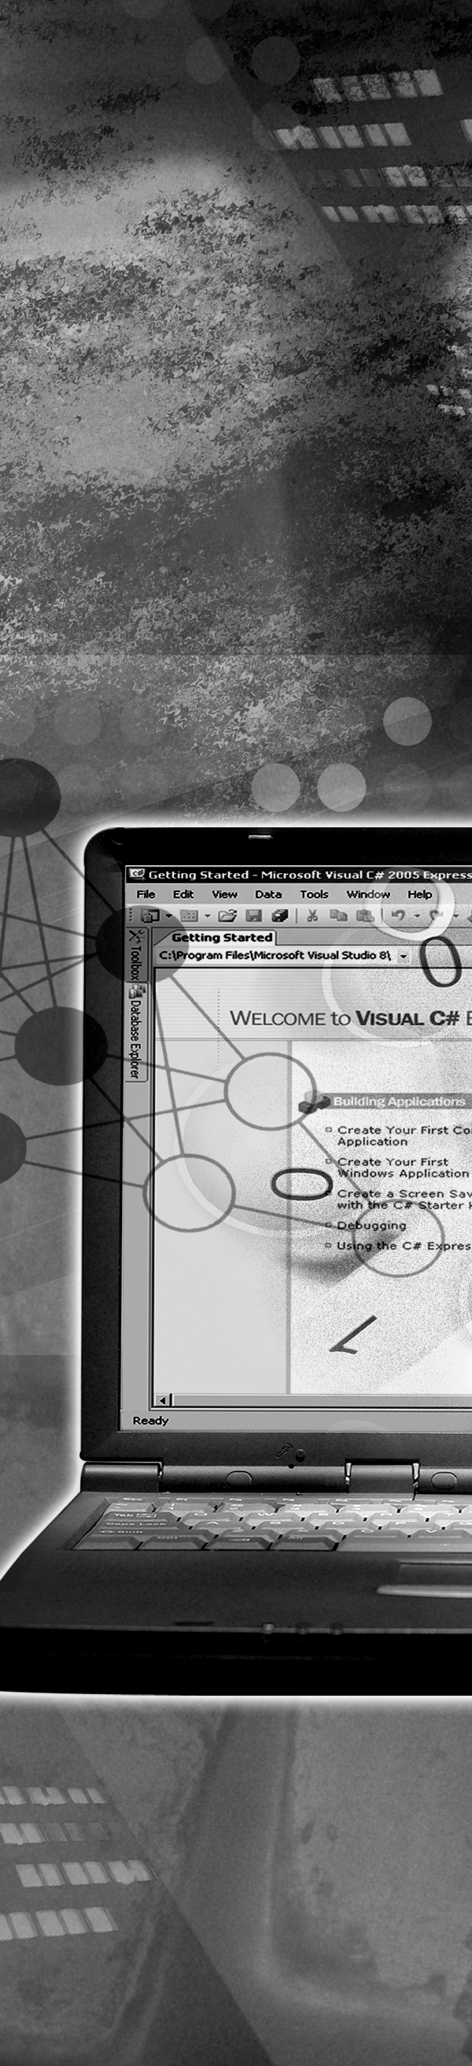
Implementation Manual

Implementation Manual
The implementation manual contains the installation steps of installing Visual Studio 2005 Professional.

Recommended System Configuration

# | TYPE | MR | OCR
1 | Number of Machines
1.1 | Faculty Node | 1 | 1
1.2 | Student Nodes | <Depends on the machine room setup> | <Depends on the class room setup>
2 | H/w Configuration
2.1 | Faculty Node | P IV – 3.0 GHz 865/915 Chipset 800 MHz FSB  FAC LEARNING) 512 MB RAM (2 * 256MB)  2 * 40 GB 7200 RPM Hard Drive  DVD CD R/W Combo drive  2 * 10/100 NIC  Optical Wheel Mouse  Keyboard  17” Color Monitor | P IV – 3.0 GHz 865/915 Chipset 800 MHz FSB  FAC LEARNING) 512 MB RAM (2 * 256MB)  2 * 40 GB 7200 RPM Hard Drive  DVD CD R/W Combo drive  2 * 10/100 NIC  Optical Wheel Mouse  Keyboard  17” Color Monitor
2.2 | Student Nodes | P IV – 3.0 GHz 865/915 Chipset 800 MHz FSB  512 MB RAM (2 * 256 MB)  80 GB 7200 RPM Hard Drive  CD ROM Drive  10/100 NIC  Optical Wheel Mouse  Keyboard  17” Color Monitor | P IV – 3.0 GHz 865/915 Chipset 800 MHz FSB  512 MB RAM (2 * 256 MB)  80 GB 7200 RPM Hard Drive  CD ROM Drive  10/100 NIC  Optical Wheel Mouse  Keyboard  17” Color Monitor
2.3 | Printer | NA | NA
3 | S/w Configuration
3.1 | First Faculty Node | Windows XP with SP2, Visual Studio 2005 Professional | Windows XP with SP2, Visual Studio 2005 Professional
3.3 | Student Nodes | Windows XP with SP 2, Visual Studio 2005 Professional | Windows XP with SP 2, Visual Studio 2005 Professional

Installing Visual Studio 2005
This guide will explain how to install Visual Studio 2005 Professional onto the C: drive but you can choose any drive and location that you wish.
Following are the steps to install Visual Studio 2005 Professional:
- Insert the Microsoft Visual 2005 Professional Disk 1 in the CD drive. The auto run feature should initiate the installer. If the installer does not run, open My Computer→CD drive→SetUp.exe. The Visual Studio 2005 Setup window is displayed.
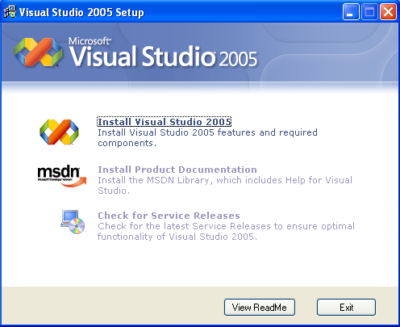
- Select Install Visual Studio 2005 hyperlink. Microsoft Visual Studio 2005 Installation wizard is displayed. The setup will load the installation components.
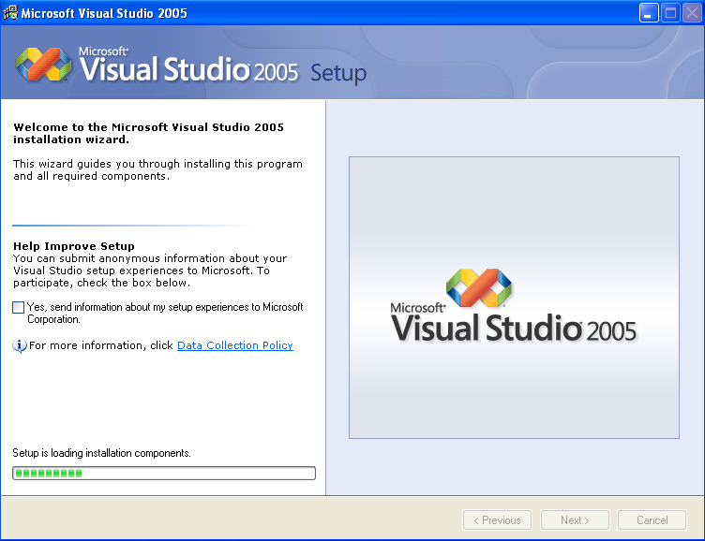
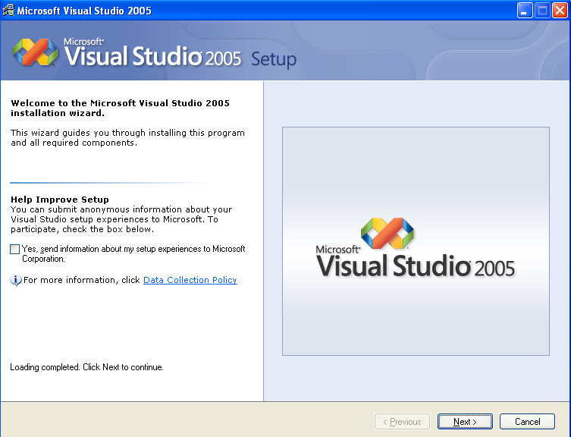
- Click the Next button. The following window is displayed.
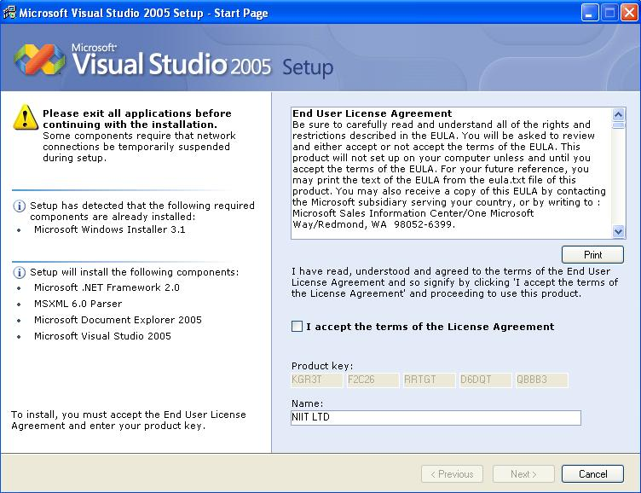
- Check the I accept the terms of the License Agreement check box.
The name in the Name text box and the product key in the Product Key text box is already entered. The Next> button will get activated.
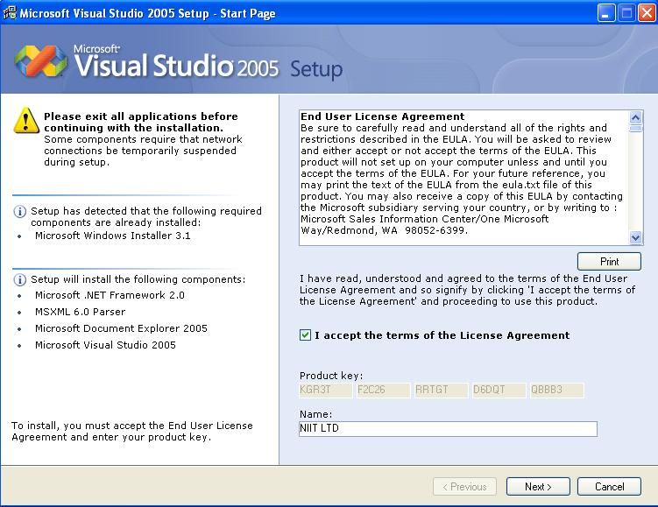


Note


The window displays the components which are already loaded in the system and components which will be loaded by the installation wizard.

- Click the Next> button. The following window is displayed.
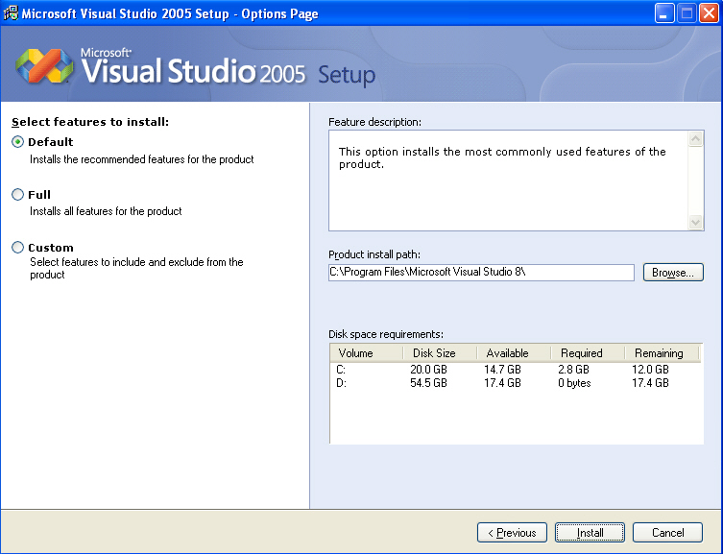
- Select the Full radio button from the Select features to install option and click the Install button. The following window is displayed.
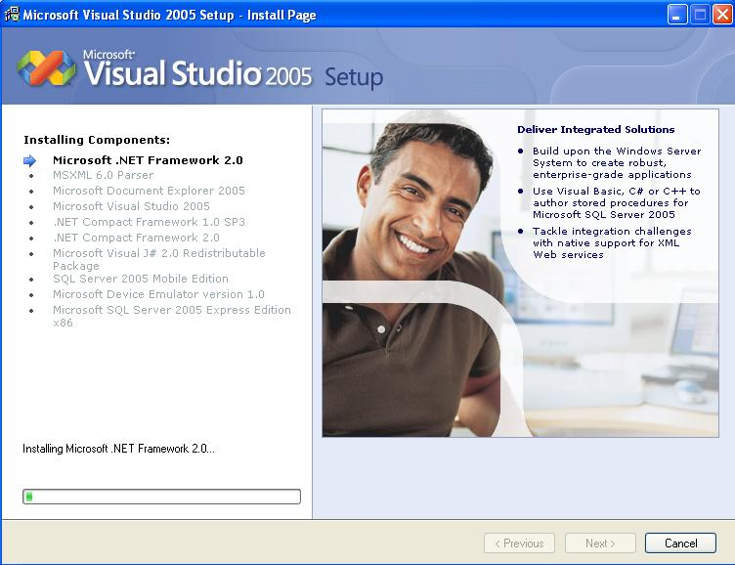

The installation process prompts to add the disk 2.
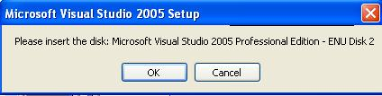
- Insert the Microsoft Visual 2005 Professional Disk 2 in the CD drive and click the OK button. The same screen of loading components is displayed. After installing all the components the following window is displayed.
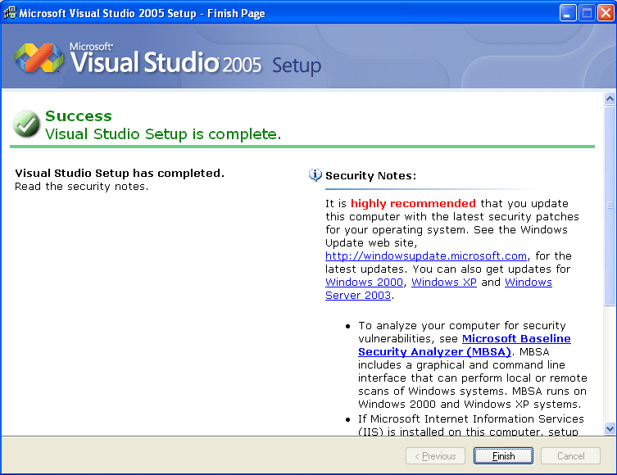

- Click on the Finish button. Microsoft Visual Studio 2005 is successfully installed. The installation process will ask to remove disk 2 and insert disk 1.
- Remove disk 2 and insert disk 1. The following window is displayed.
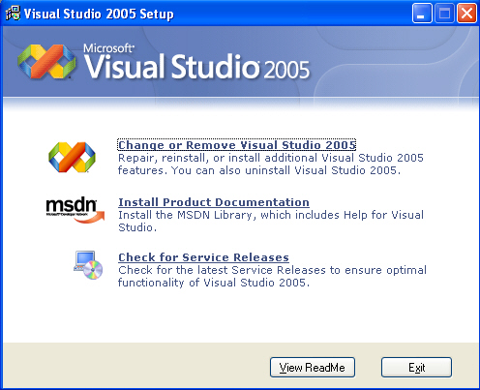

- Click the Exit button
Implementation Manual
The implementation manual contains the installation steps for installing HTML Help Workshop 1.3.

Installing HTML Help Workshop 1.3
This guide will explain how to install HTML Help Workshop 1.3 onto the C: drive but you can choose any drive and location that you wish.
Following are the steps to install HTML Help Workshop 1.3:
- Double-click the HTMLHELP.exe file present in the Support Software folder under the TIRM folder. The license agreement window is displayed.
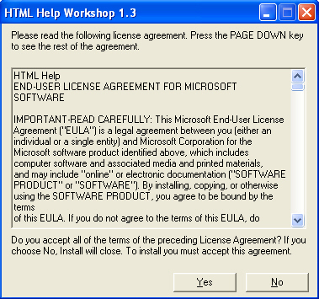
- Click the Yes button to accept the agreement. The setup will extract files.
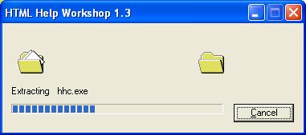
After extraction the following widow is displayed.
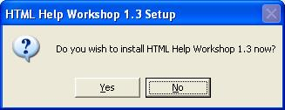
- Click the Yes button. The following window is displayed.
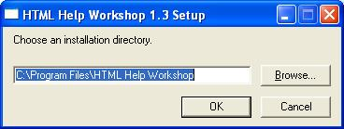
- Click the OK button to install HTML Help Workshop 1.3. If required, you can change the installation directory by clicking the Browse button.
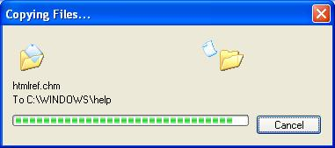

After installation the following widow is displayed.
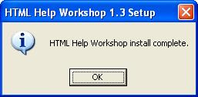
- Click the OK button.

